Temperature documentation

**DHT11 (blue with holes) sensor:**

See DHT11 test file for code. The resistor is a 10K Ohm resistor.

Must install both the Adafruit and DHT11 sensor library.

Humidity has an accuracy of +- 5%.

Temperature has an accuracy of +- 2 degrees Celsius.

2.5 mA = max current use.

Can be used both at 3.3V and 5V.

**BME280 (purple with 6 pins) sensor:m**

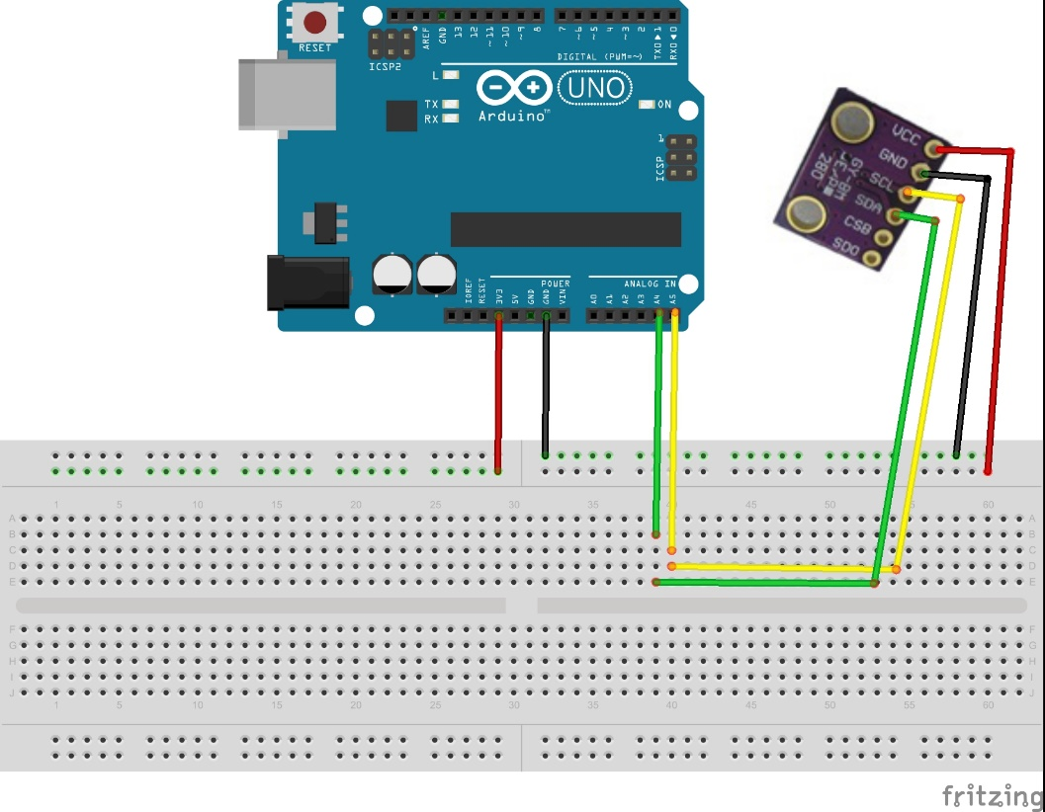

See BME280 test file for code.

Must install both the Adafruit and BME280 sensor library.

Humidity has an accuracy of +- 3%.

Temperature has an accuracy of +- 1 degrees Celsius.

3.6 µA = current use.

Must be used at 3.3V. If the usage of 5 is involved, must use voltage regulators (resistors), since it does not have one.

Note: CSB and SDO pins are not used.